Workflow Functional Document

Application | NGERP - Centra
Workflow | Quote to Cash
Workflow Item Name | Customer Return

Description:

In Compiere ERP, Customer Return refers to the process where a customer returns goods they previously purchased. This could be due to reasons such as product defects, dissatisfaction, or other customer service policies.
After the return order is entered, create a Credit Memo to adjust the customer’s balance.

Workflow Process:

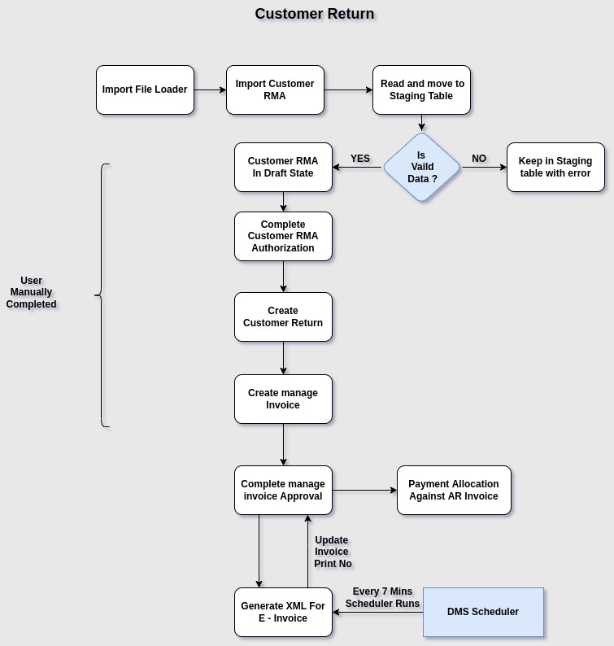

Business Rules:

- Customer Return can be created in two ways by Importing Customer RMA or by creating it manually in the Customer RMA window.
- If we create a Customer RMA by importing the file, we use the Import File Loader to load the file.
- The Import File name starts with ‘ImportCustomerRMA.csv’
- Import Data will be stored in the I_Order staging table.
- During the import process, certain validations are performed, such as ensuring that the Order and
Expiration Date are not empty, the Price list is mapped, the Business Line is filled, RMA Category, Sales
Order Document No, Warehouse, Location, Product, and valid Tax information are provided, etc.
- In case of an error during the import process, the import file will remain in the staging table with the 'NO' status. If no error occurs, it will move to the Customer RMA screen.
- The user will manually complete the Customer RMA using the Customer RMA Authorization.
- Create a Customer Return mapped with the RMA transaction to complete the return process.
- Create a Manage Invoice using the 'AR Credit Memo' document type, associated with the Return
Document No, to complete the invoice process via the Manage Invoice Approval screen
- When the return is processed, the inventory is updated to reflect the return of goods and adjusts the
inventory levels based on the items and quantities returned.
- Generates accounting journal entries related to the return process, ensuring that all financial transactions, such as the reduction in revenue and inventory, are properly recorded.
- Create a payment for the return transaction and allocate it using the Payment Allocation form.
- Generate the E-invoice XML for the AR Credit Memo invoice
- The DMS Scheduler process updates the Invoice Print Number in the Manage Invoice screen.
- The DMS scheduler will run every 7 minutes in daily.

